Warehouse Wizard WMS Proposal
Cloud-Hosted Warehouse Management System
Prepared for: Matthew Hunte | Prepared by: Russell Hunte | May 2026

Table of Contents
1. Executive Summary
2. Business Challenge
3. Proposed Solution
4. Core Features & Capabilities
5. Investment & Pricing Options
6. Implementation Roadmap
7. Why Warehouse Wizard
8. Next Steps

1. Executive Summary
Dear Matthew,
Thank you for the opportunity to present the Warehouse Wizard Warehouse Management System. This proposal outlines a practical, cloud-hosted solution designed to help you move from manual, spreadsheet-based processes to a more structured, efficient, and scalable system.
Warehouse Wizard addresses common challenges facing growing distribution businesses: improving visibility into where products are stored, supporting better space utilization, helping reduce picking errors, and maintaining operational control as your business scales.
Our recommended Professional WMS Package provides broad warehouse control at USD $750 per month with a first-year investment of $17,900, supporting near-term operational improvements and long-term scalability.

2. Business Challenge
Many growing distribution businesses face significant operational challenges when relying on manual warehouse management methods:
- Staff uncertainty about product locations leading to time waste and frustration
- Misplaced or forgotten inventory resulting in lost sales opportunities
- Inefficient warehouse space utilization reducing storage capacity
- Increased picking and dispatch errors affecting customer satisfaction
- Inadequate receiving documentation creating inventory discrepancies
- Limited management visibility into warehouse operations and performance
- Time-consuming stock counts disrupting daily operations
These challenges can become more expensive as warehouse operations grow. The cost of inefficiency can compound - what starts as minor inconveniences may evolve into operational bottlenecks that impact customer service, staff productivity, and business profitability.

3. Proposed Solution
Warehouse Wizard provides a structured, cloud-hosted warehouse management system built around your physical warehouse layout. The system supports day-to-day warehouse operations by providing:

Complete Location Management
The system represents your warehouse structure including zones, aisles, racks, bays, levels, and depth positions. Storage locations are mapped and tracked, helping staff locate products faster and make better use of available space.
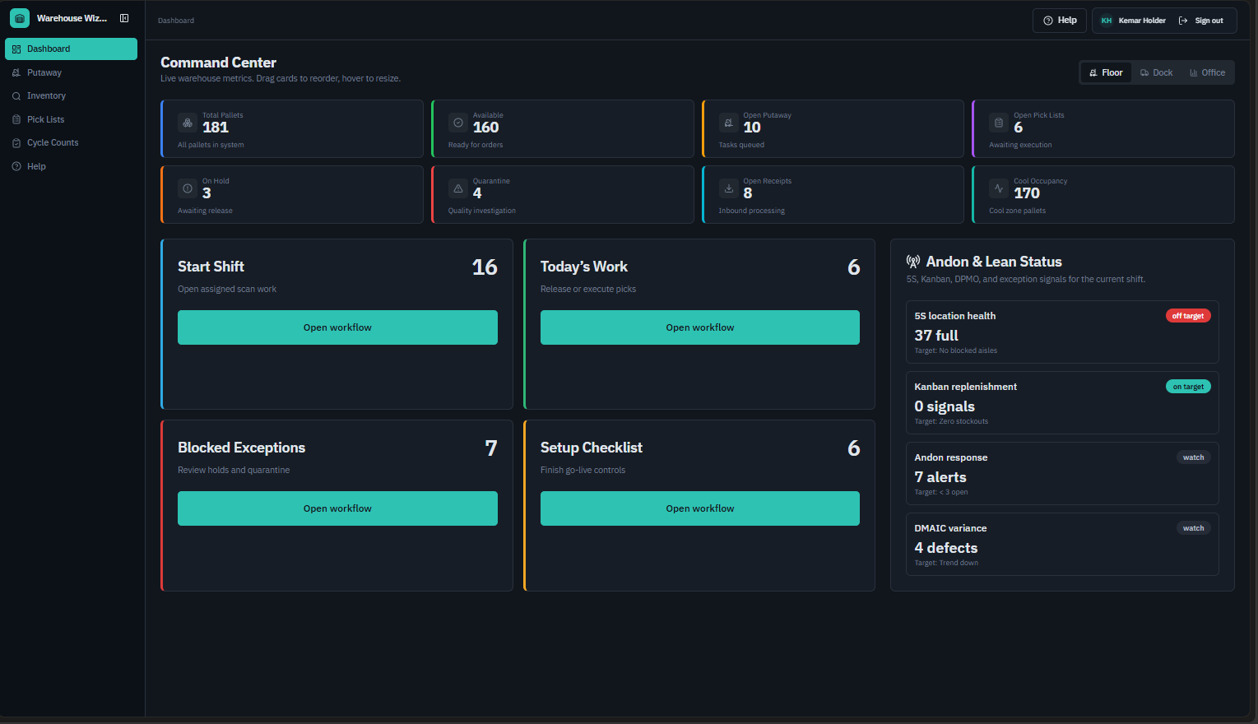

Guided Product Assignment
Warehouse Wizard uses product characteristics (size, weight, category, storage requirements) and warehouse constraints (capacity, accessibility, safety) to suggest suitable storage locations. This guided assignment can reduce handling time and improve warehouse organization.
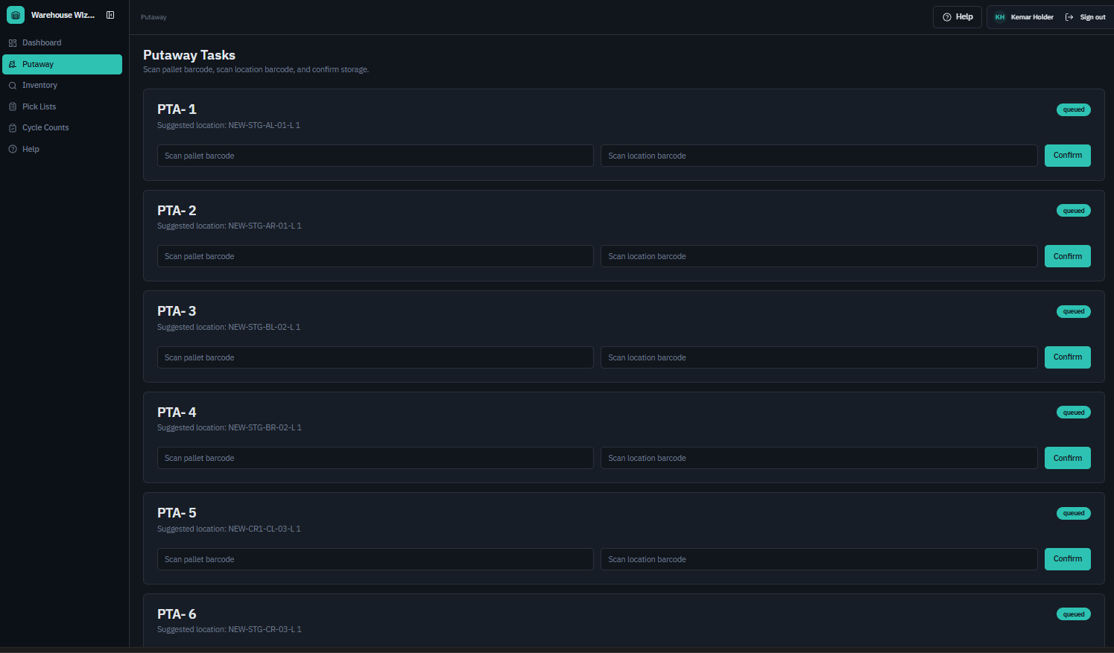

Operational Control & Visibility
Tracking of receiving, movement, picking, and dispatch activities provides management with up-to-date visibility into warehouse operations. Actions can be recorded with user accountability, supporting an audit trail.
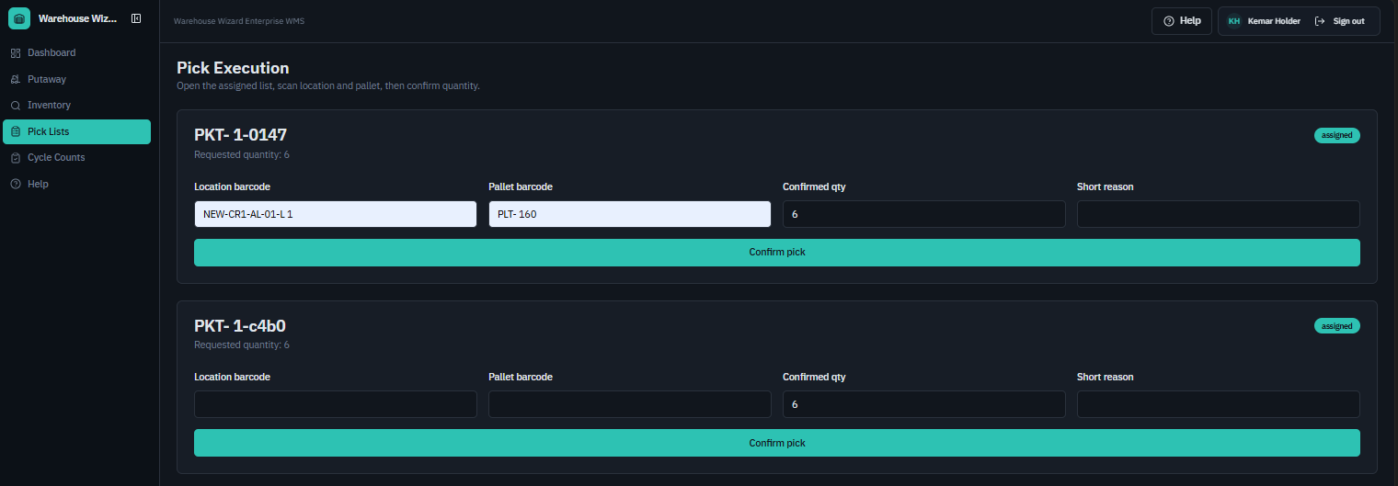

4. Core Features & Capabilities
Feature Category | Key Capabilities
Warehouse Setup | - Create zones, aisles, racks, levels, and depth positions  - Assign names or codes to every storage space  - Mark spaces as available, occupied, reserved, or blocked  - Identify special storage areas (cold storage, fragile goods, bulk storage)
Inventory Control | - Product master file with SKU, barcode, and specifications  - Up-to-date stock search by product, location, supplier, or category  - Stock movement tracking with an audit history  - Stock adjustment and count management
Operations | - Receiving with automatic location assignment suggestions  - Pick list generation with suggested warehouse locations  - Dispatch tracking and documentation  - User permissions and role-based access control
Reporting & Analytics | - Inventory reports by product and location  - Warehouse utilization and space availability reports  - Movement history and audit trails  - Slow-moving stock and low-stock alerts

5. Investment & Pricing Options
Warehouse Wizard offers three investment levels to match your operational requirements and growth trajectory:
Package | Monthly Cost | Setup Fee | First Year Total
Starter Package | $450 | $7,100 | $12,500
Professional WMS | $750 | $8,900 | $17,900
Enterprise Package | From $3,500 | From $18,000 | From $60,000

Recommended: Professional WMS Package
Based on your operational requirements, we recommend the Professional WMS Package. This package provides comprehensive warehouse control capabilities without the complexity and cost of enterprise-level deployment.
The Professional package includes:
- Advanced location structure with product rules and put-away support
- Complete receiving, movement, picking, and dispatch functionality
- Stock count module with audit trail and user permissions
- Warehouse utilization and management reporting
- Support for up to 18 users with role-based access
- Barcode scanner support

6. Implementation Roadmap
Our 6-phase implementation approach is designed to support a smooth deployment with minimal disruption to your operations. The Professional WMS Package typically requires 4-8 weeks for complete implementation.

Phase 1: Discovery & Warehouse Mapping (Week 1)
- Review warehouse layout and identify zones, aisles, racks, and storage types
- Confirm product categories and storage rules
- Define users and permission levels
- Agree on initial system configuration

Phase 2: Cloud System Setup (Weeks 2-3)
- Create and configure your Warehouse Wizard cloud environment
- Set up warehouse structure and storage positions
- Create user accounts and test system access
- Validate all core functions

Phase 3: Product Data & Inventory Setup (Week 4)
- Import product master file including SKU, barcode, description, and specifications
- Assign products to storage locations based on agreed put-away rules
- Conduct opening stock count and load initial inventory balances
- Verify data accuracy and resolve any discrepancies before go-live

Phase 4: Staff Training (Week 5)
- Conduct role-based training sessions for warehouse staff, supervisors, and managers
- Train users on receiving, picking, dispatch, stock counting, and reporting workflows
- Confirm barcode scanner setup and test with all user devices
- Sign off on training completion with key users before go-live

Phase 5: Go-Live & Hypercare Support (Weeks 6-7)
- Transition warehouse operations to live system with dedicated support on-hand
- Monitor system performance and resolve any day-one issues promptly
- Provide daily check-ins with your team during the first two weeks of operation
- Confirm all core workflows are operating correctly under real-world conditions

Phase 6: Post-Implementation Review (Week 8)
- Conduct a structured review session with your team to assess system performance
- Identify and address any configuration adjustments or workflow refinements needed
- Confirm handover to ongoing support and document any outstanding items
- Agree on ongoing support arrangements and escalation procedures

7. Why Warehouse Wizard
Warehouse Wizard is built for practical warehouse control. Unlike complex enterprise systems that overwhelm users with unnecessary features, Warehouse Wizard focuses on answering the questions that matter every day:
"Where is the product?" • "How much do we have?" • "Where should this item go?"
"Who moved it?" • "What needs to be picked?" • "What space is available?"

Key Advantages
- Cloud-hosted deployment - No server infrastructure required, faster implementation, automatic updates
- Scalable architecture - Grows with your business from single warehouse to multi-location operations
- Practical focus - Designed for day-to-day warehouse operations, not unnecessary complexity
- Cost-effective - Professional capabilities without enterprise complexity and cost
- Structured implementation approach - Clear rollout process with training and support

8. Next Steps
To move forward with the Warehouse Wizard implementation, I recommend the following approach:

Immediate Actions
- Lets have a call to clear up any questions.
- Schedule a warehouse walkthrough to review your current layout and discuss specific requirements
- Confirm the Professional WMS Package meets your operational needs and budget requirements
- Review implementation timeline and identify optimal go-live timing for your business

Investment Summary
Professional WMS Package: USD $750 per month
Implementation and setup: USD $8,900
Estimated first-year investment: USD $17,900
Minimum term: 12 months

Commercial Terms (Refunds, Support & Non-Payment)
Minimum term: This subscription is offered on a minimum 12-month term.
Refund policy: Subscription and implementation fees are committed upon engagement. As work begins immediately upon sign-off, fees paid are not refundable if a project is paused or discontinued after commencement. We are committed to delivering value and will work closely with you to ensure the system meets your needs.
Stabilization support: If issues arise after go-live that prevent normal use of agreed core functions, we will work with your team to stabilize the system through configuration adjustments, troubleshooting, and defect fixes until it is operating as expected. This applies where the system is used as intended and standard requirements (internet connectivity, compatible devices, and accurate data) are in place.
Non-payment: Invoices are due on the agreed dates. If an account falls significantly overdue, we will contact you to discuss the situation. Where a balance remains unresolved after reasonable notice, we reserve the right to temporarily suspend access until the outstanding amount is settled. We will always aim to communicate early and work with you on any payment concerns.
I would be pleased to discuss the next steps, review your warehouse requirements in detail, and confirm the best package for your operation. Please feel free to contact me directly with any questions.
This proposal is valid for 30 days from the date of issue (May 2026). Pricing and terms are subject to change after this period.
Regards,
Russell Hunte
Warehouse Wizard Implementation Specialist and Developer
Email: threedesign2023@outlook.com

Proposal Acceptance
By signing below, you confirm your acceptance of the Warehouse Wizard Professional WMS Package as described in this proposal, including the commercial terms outlined above.
Client Name: ___________________________________________
Signature: _____________________________________________
Date: __________________________________________________

